**Data Analysis & Visualization on LFPR, WPR & UR (ps + ss)**

**In PLFS terminology,**

* **PS+SS refers to the Principal Status + Subsidiary Status approach. It measures:**
  + **Principal Status (PS): The person’s main activity during the majority of the year (6 months or more).**
  + **Subsidiary Status (SS): Additional activities the person is engaged in for less than 6 months.**
* **Thus, PS+SS offers a comprehensive picture of employment, considering both primary and supplementary activities.**

**A) Labour Force Participation Rate (LFPR)**

* **LFPR refers to the percentage of the working-age population (15 years and above) that is either employed or actively looking for work.**
* **It shows how many people are willing and available to work.**
* **High LFPR → More people participating in the labour force.**
* **Low LFPR → More people out of the labour market due to:**
  + **Lack of opportunities**
  + **Education**
  + **Domestic responsibilities**

**Plot LFPR 1**

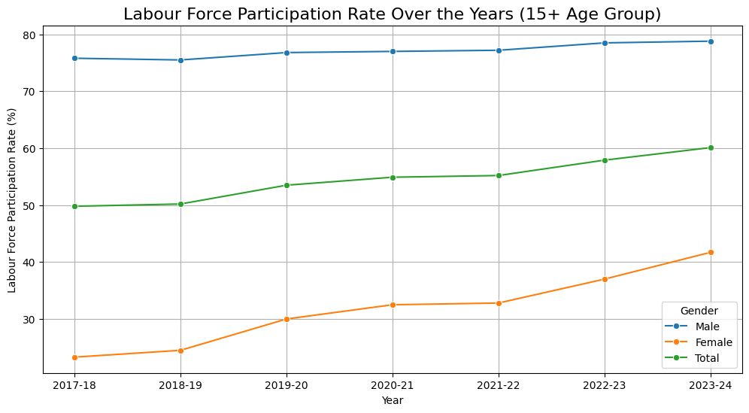

**Overall increase: LFPR grew from 49.8% in 2017-18 to 60.1% in 2023-24, indicating a consistent improvement.**

**Male dominance: Male participation remains higher, but female participation is rising at a faster rate, closing the gender gap.**

**Plot LFPR 2**

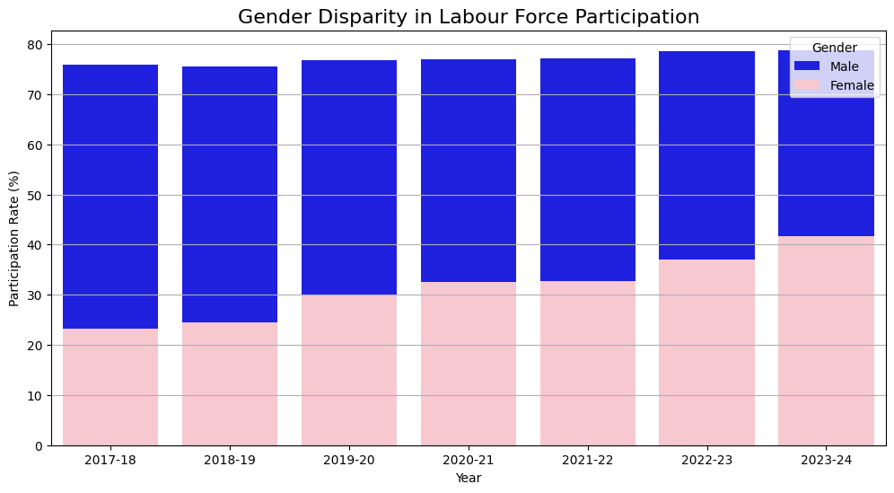

**Persistent gender gap: Male participation is significantly higher, although female participation has increased from 23.3% (2017-18) to 41.7% (2023-24).**

**Plot LFPR 3**

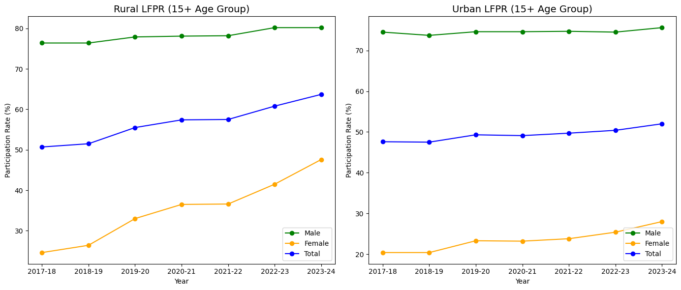

**Rural participation is consistently higher than urban participation, driven by agricultural jobs.**

**Urban participation shows a slower but steady increase, indicating rising non-agricultural employment.**

**Plot LFPR 4**

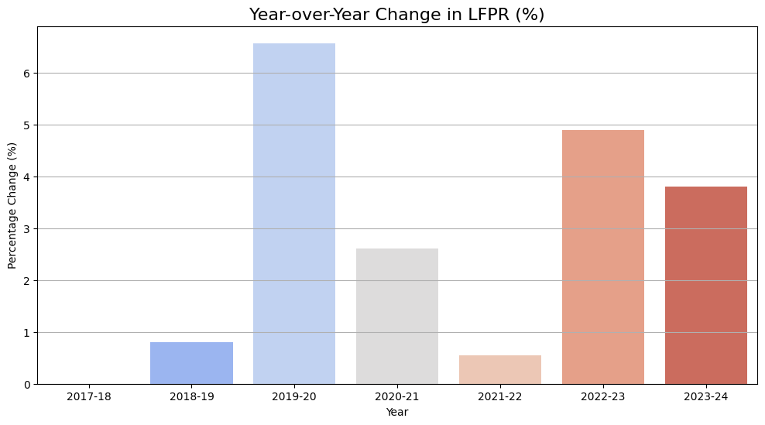

**The largest growth was between 2021-22 and 2022-23, with a significant rise in participation.**

**Positive YoY growth throughout the years highlights consistent economic recovery.**

**Plot LFPR 5**

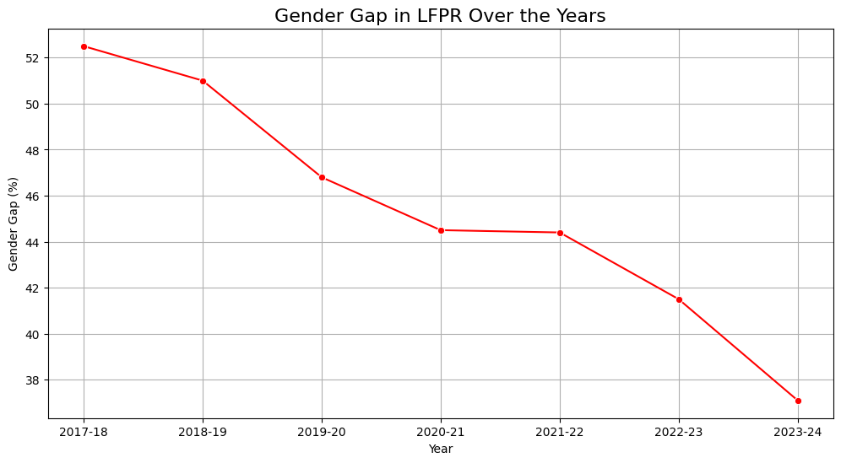

**The gender gap reduced from 52.5% in 2017-18 to 37.1% in 2023-24, indicating gradual progress.**

**Plot LFPR 6**

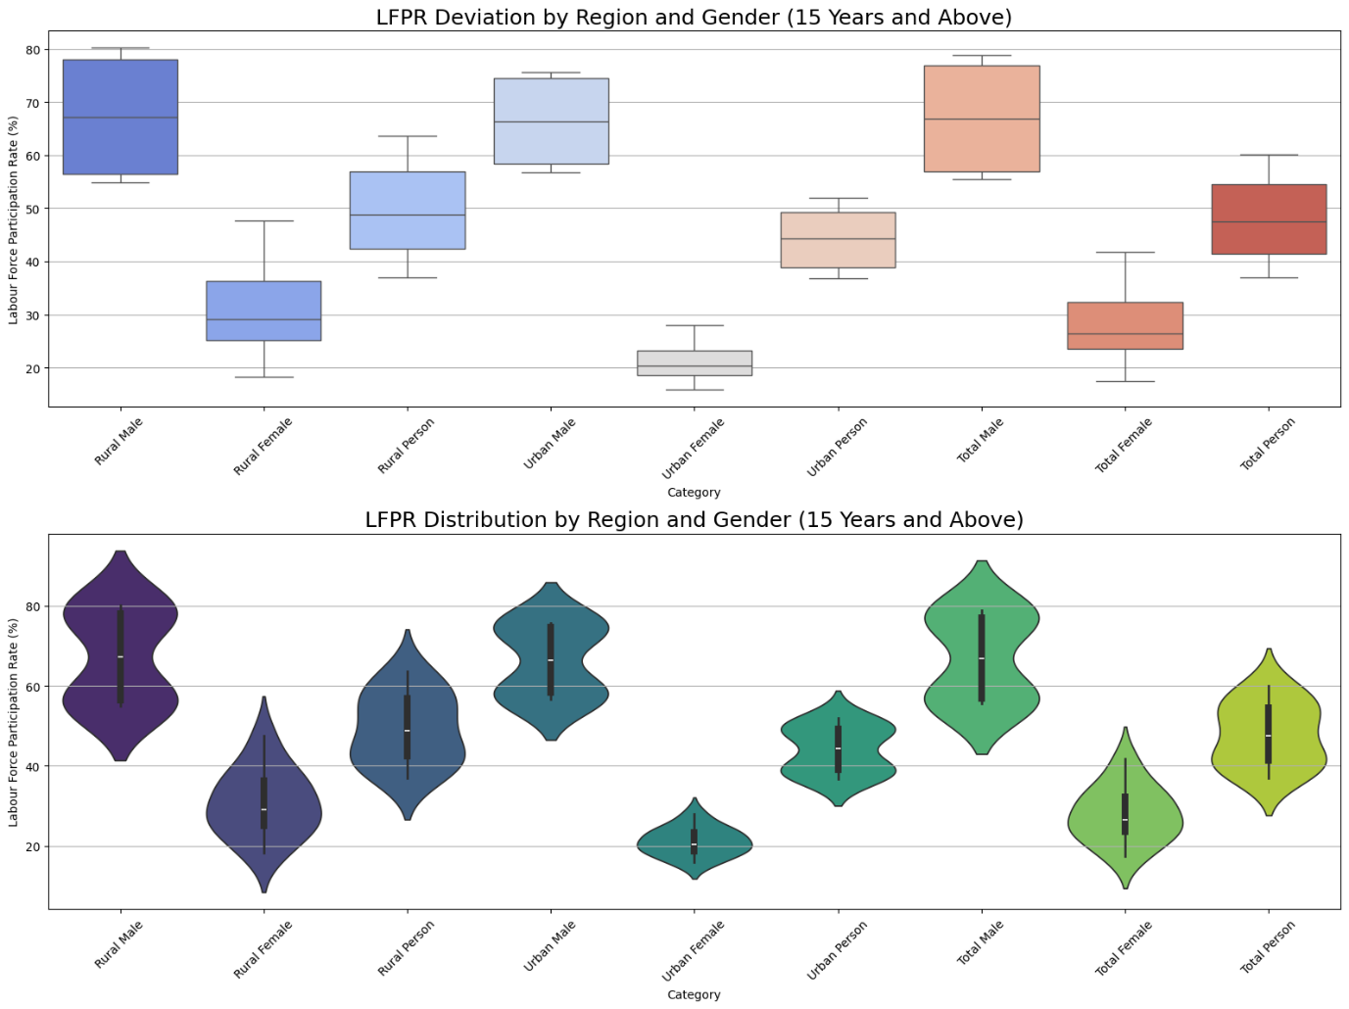

* **Rural Female LFPR shows occasional low outliers, indicating drops in participation.**
* **Total Female LFPR also has low outliers, reflecting volatility.**
* **Urban LFPR is more stable with fewer outliers and compact distributions.**
* **Male LFPR is consistently higher and more stable than female LFPR.**
* **Female LFPR shows greater variability with more outliers.**
* **Urban violins are thicker around the median, indicating consistent participation.**
* **Rural violins are wider, highlighting higher volatility, especially for females.**

**B) Worker Population Ratio (WPR)**

* **WPR refers to the percentage of the working-age population that is actually employed.**
* **It measures the extent of employment in the labor force.**
* **Higher WPR → More people are employed.**
* **Lower WPR → Higher unemployment or inactivity.**

**Plot WPR 1**

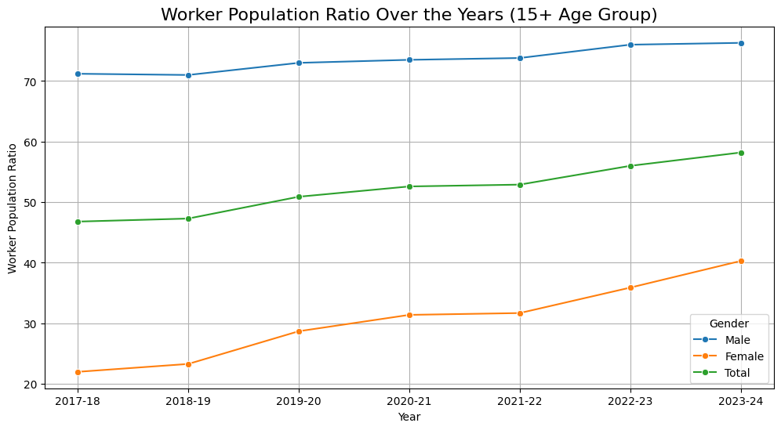

**WPR has generally increased from 2017-18 to 2023-24 for the 15+ age group, with a faster rise in female participation compared to males, although the gap persists. Overall, the total WPR has shown a consistent upward trend indicating positive workforce participation growth over the years.**

**Plot WPR 2**

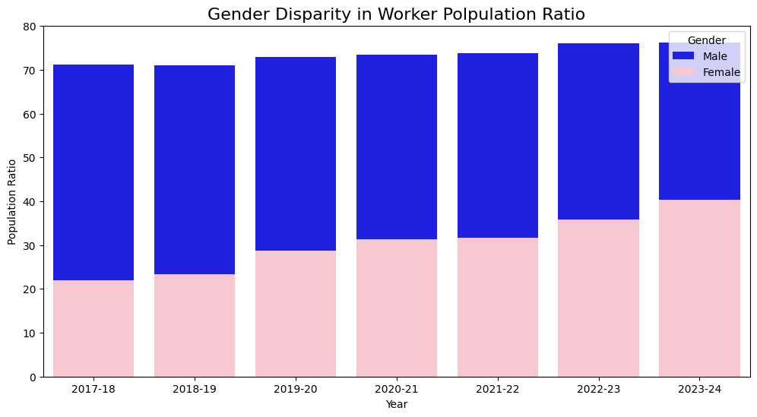

**This visualizes the gender disparity in workforce participation using a bar plot, highlighting the consistently higher participation of males compared to females across the years, although a gradual increase in female participation is observed. This suggests a persistent gender gap in the workforce, despite some positive changes over time.**

**Plot WPR 3**

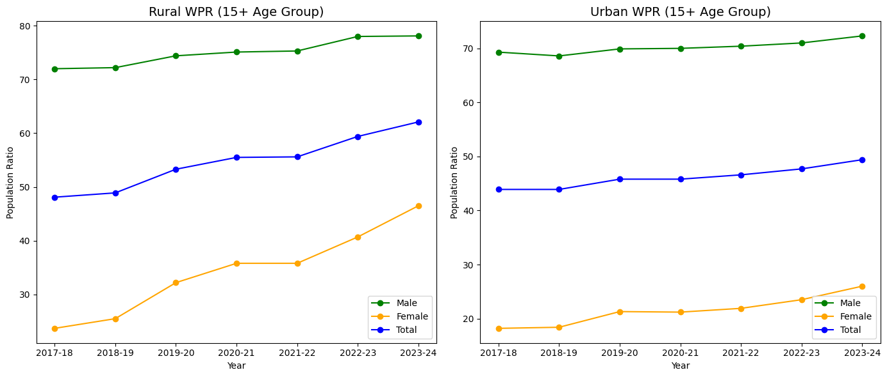

**Rural WPR is consistently higher than urban WPR, but urban WPR shows a slower but steady increase, indicating rising non-agricultural employment. This difference in trends highlights the varying economic structures and opportunities in rural and urban areas, influencing workforce participation.**

**Plot WPR 4**

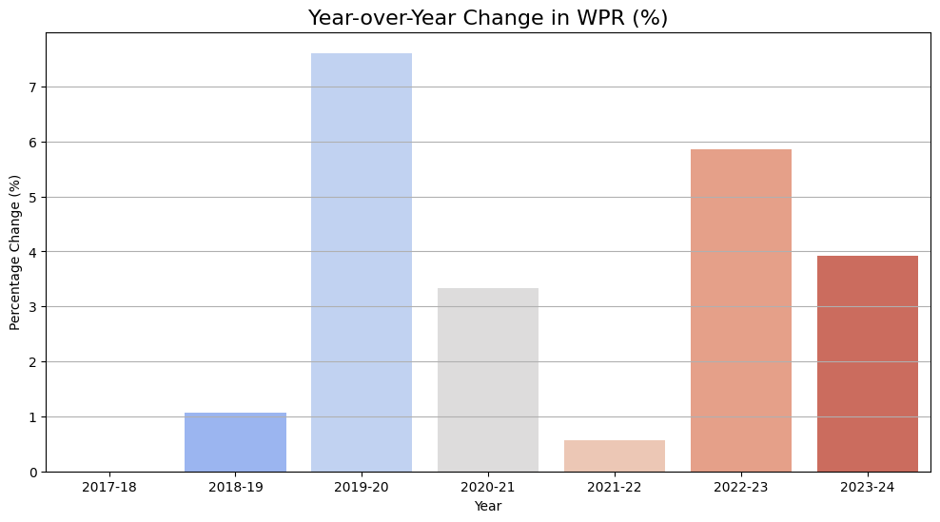

**The WPR shows a general upward trend with the most significant growth occurring between 2017-18 and 2019-20, and between 2021-22 and 2022-23, suggesting periods of economic improvement or policy impact. Despite some volatility, the overall positive year-over-year changes indicate a consistent improvement in workforce participation.**

**Plot WPR 5**

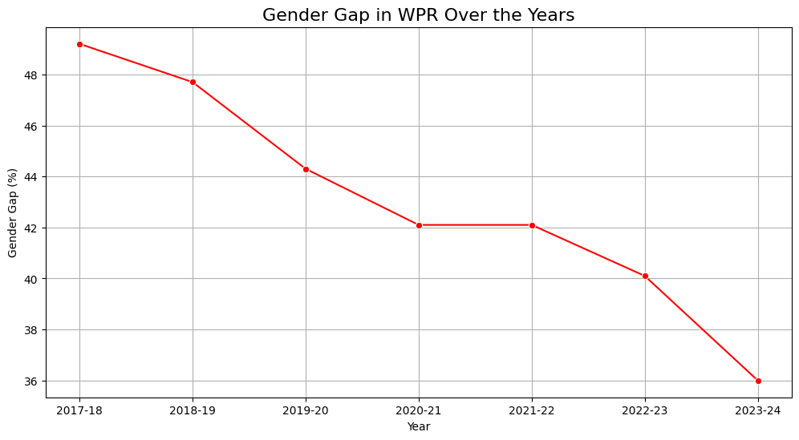

**The visualization reveals a persistent gender gap in worker participation, with men consistently having higher rates than women. However, the gap appears to be gradually narrowing over the years, indicating slow but positive progress towards greater workforce equality.**

**Plot WPR 6**

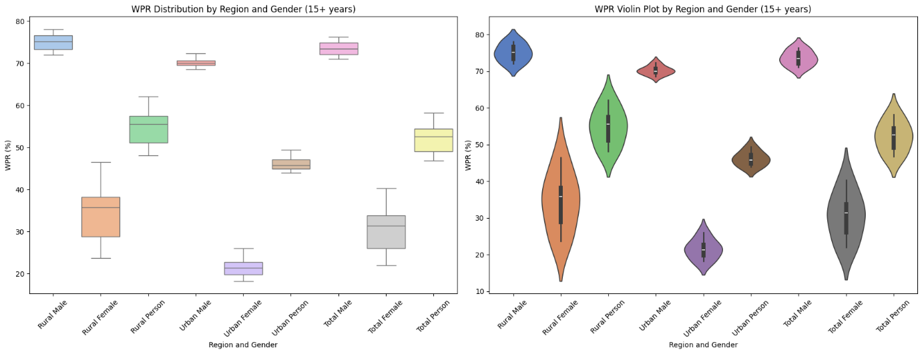

**The distribution of male WPR is more concentrated and stable compared to females, indicating less fluctuation in male employment patterns over time.**

**Female WPR distributions are wider and show more outliers, reflecting greater variability and potential employment fluctuations for women due to socio-economic factors or policy changes.**

**C) Unemployment Rate (UR)**

* **UR refers to the percentage of the labour force that is unemployed but actively seeking work.**
* **It reveals the demand-supply gap in the job market.**
* **Higher UR → More people actively seeking work but unable to find it.**
* **Lower UR → Fewer unemployed people or more job opportunities.**

**Plot UR 1**

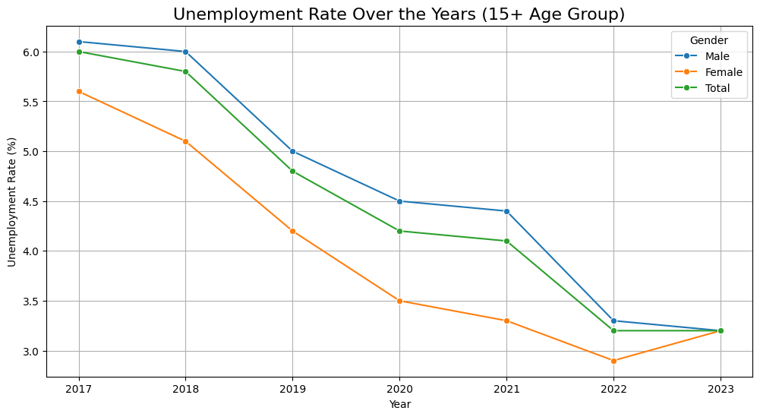

**Unemployment rates for the 15+ age group show a decline over time, with females experiencing higher unemployment rates compared to males. Overall, the unemployment rate is decreasing but a gender gap in unemployment persists.**

**Plot UR 2**

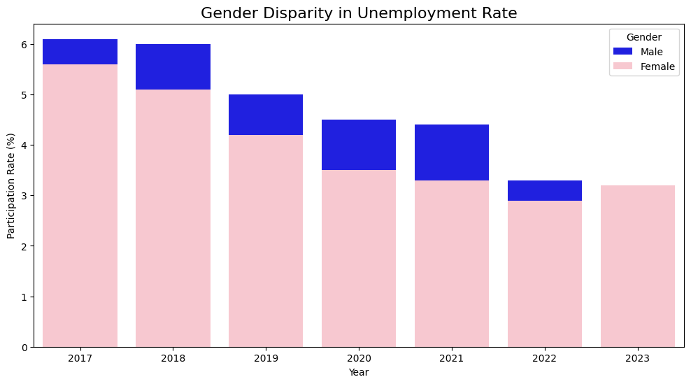

**The bar plot reveals a consistent gender gap in unemployment rates over the years, with female unemployment generally higher than male unemployment. Although both male and female unemployment rates appear to be generally declining over time, the disparity between them persists.**

**Plot UR 3**

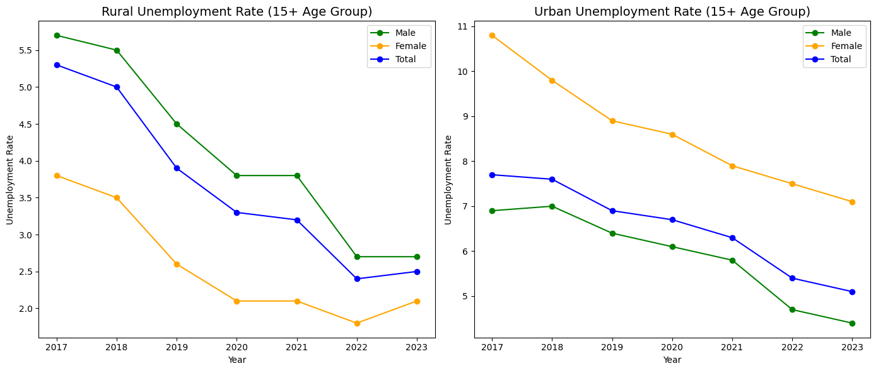

**The code visualizes rural and urban unemployment rates over time for males, females, and the total population using line plots. The visualization reveals that rural unemployment is generally lower than urban, and that there are gender disparities in unemployment rates across locations, particularly in urban areas.**

**Plot UR 4**

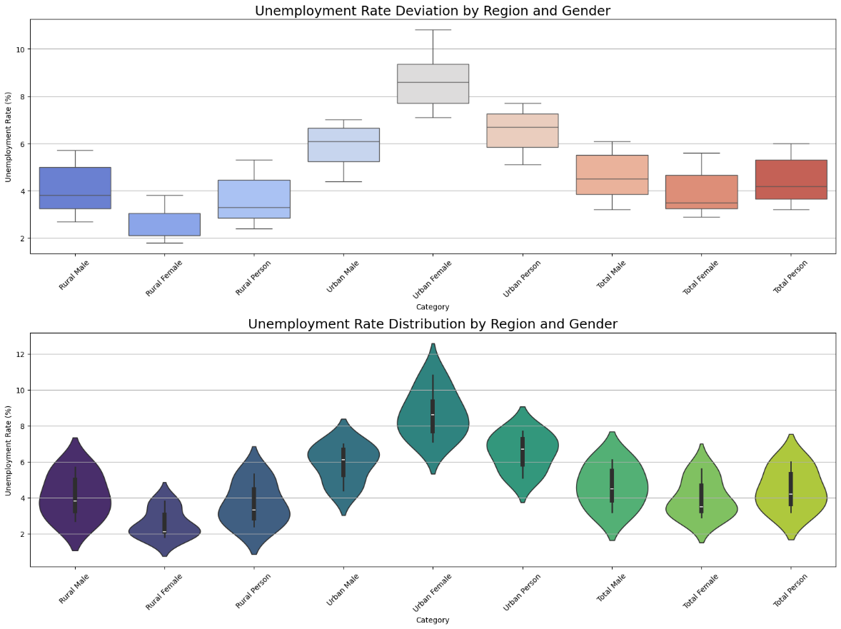

**The visualizations reveal that urban females consistently experience the highest unemployment rates with significant variability, while rural areas generally have lower unemployment. A persistent gender gap exists, with females facing high&er unemployment than males across both regions.**